Michael DePouw
COT4932

Electronic Codebook Mode (ECB) – In ECB the data block is passed directly to the DES input block.
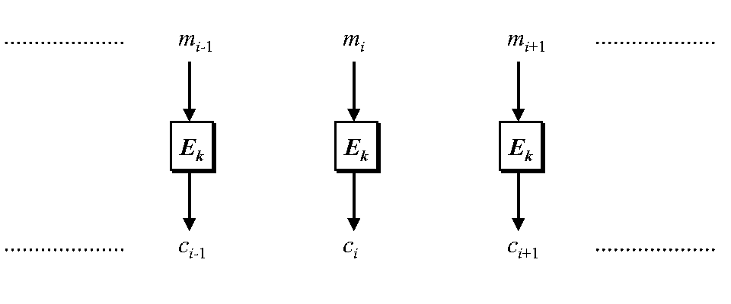
Cipher Block Chaining Mode (CBC) – In CBC the plaintext block is XORed with the previous ciphertext.
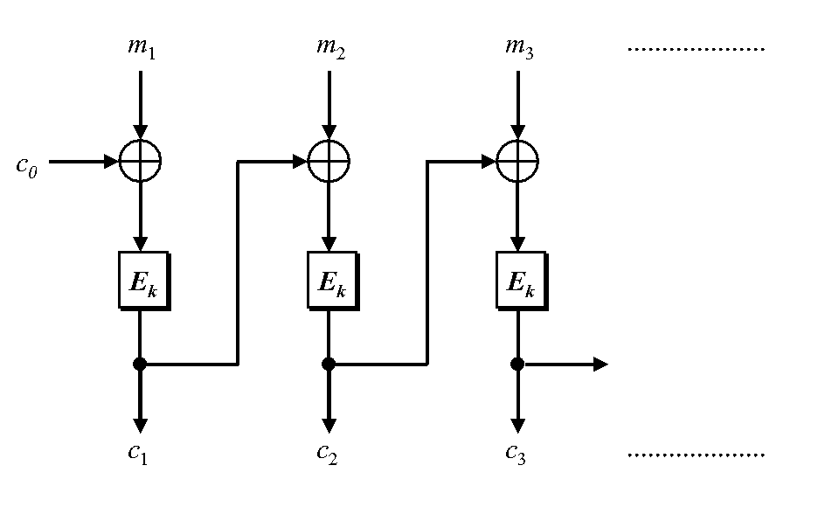
Cipher Feedback Mode (CFB) – In CFB the previous cipher text is encrypted and then XORed with data input block to produce the current cipher block.
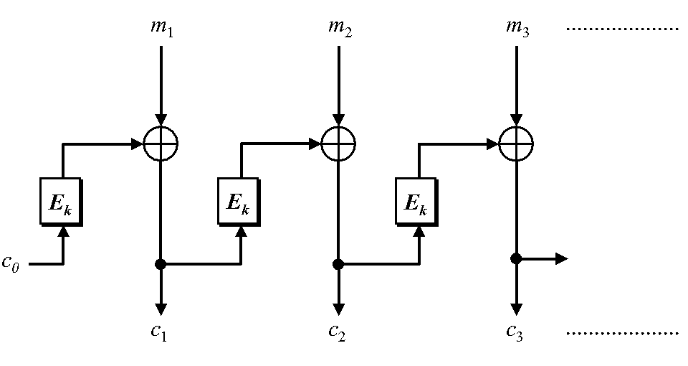
Output Feedback Mode (OFM) – In OFM a vector s is encrypted and then XORed with the data input block. S is independent of ciphertext and plaintext.
